**Assignment Week 1**

**Harshdeep Shrivastava**

**20BCY10068**

ls: List files and directories

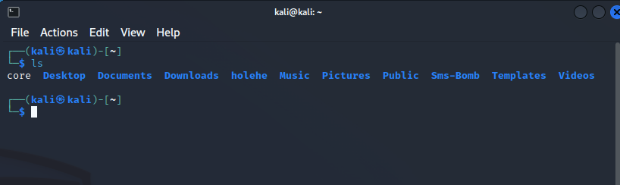

cd: Change directory

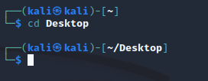

pwd: Print working directory

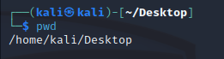

mkdir: Make directory

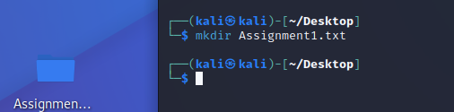

touch: Create an empty file

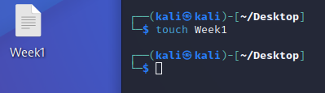

cp: Copy files and directories

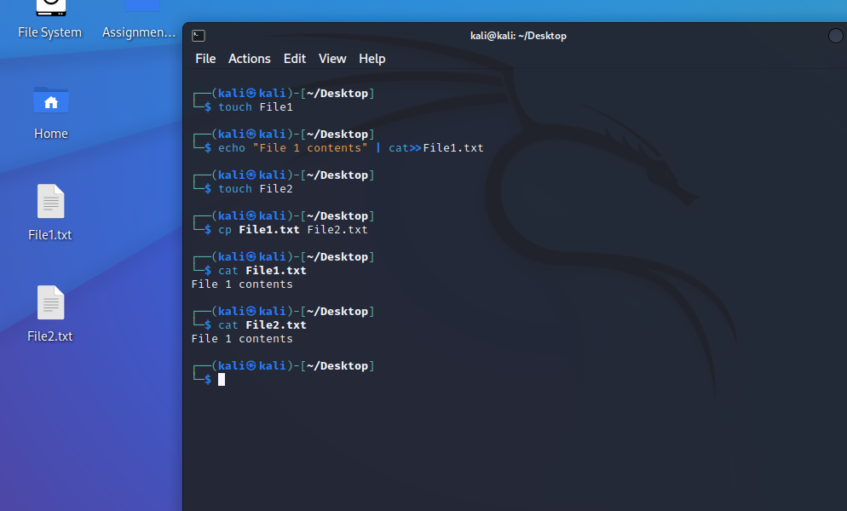

mv: Move or rename files and directories

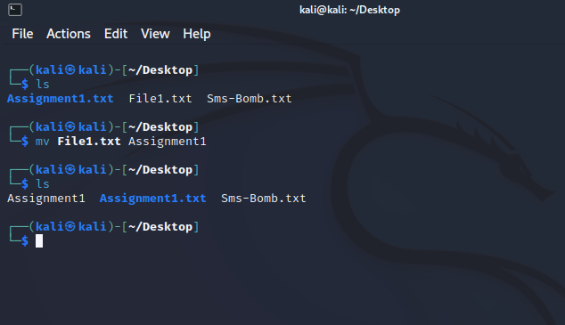

rm: Remove files and directories

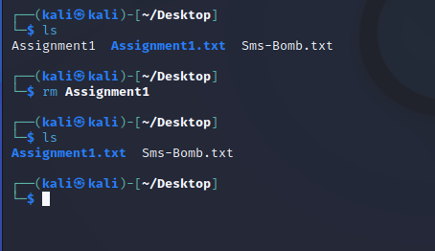

find: Search for files and directories

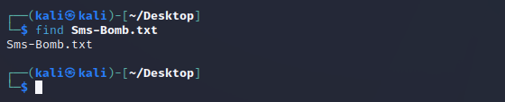

cat: Concatenate and display file content

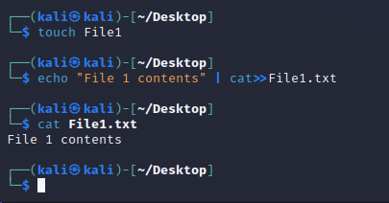

less: View file content with pagination

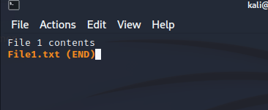

head: Display the beginning of a file



tail: Display the end of a file

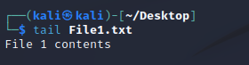

nano: Text editor for creating and editing files

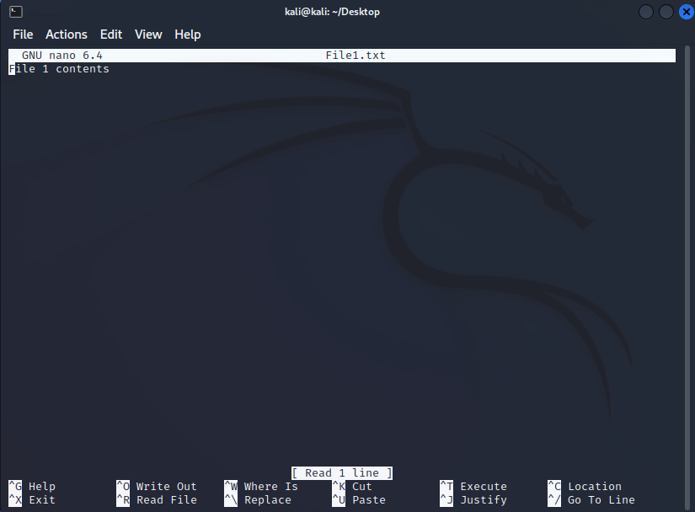

vi/vim: Powerful text editor for experienced users

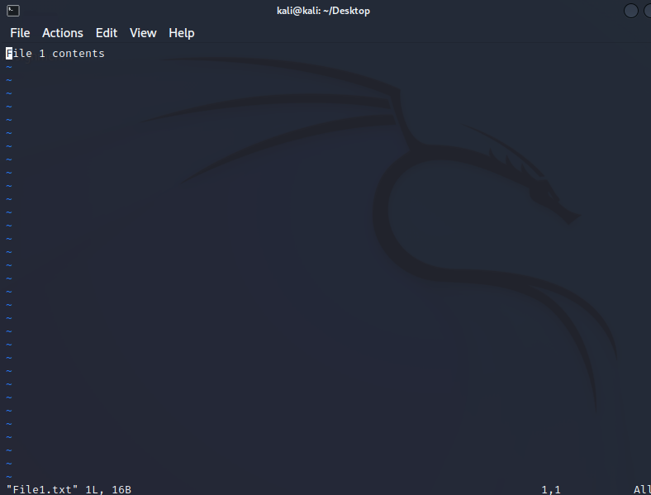

chmod: Change file permissions



chown: Change file owner



chgrp: Change file group

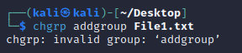

tar: Archive files

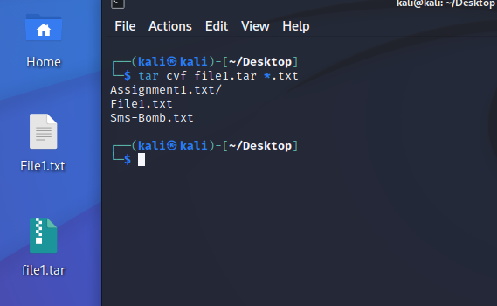

gzip: Compress files

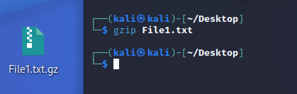

unzip: Extract files from a ZIP archive

